HOW TO CONFIGURE FLOAT STATIC ROUTING

FLOAT STATIC ROUTING CONFIGURATION

Inacio Andre

2024

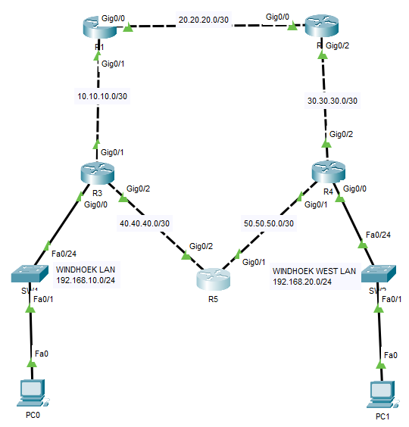

ROUTER 3

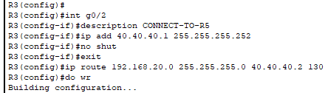

ROUTER 4

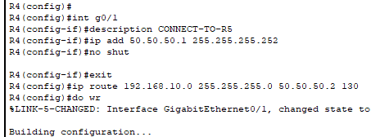

ROUTER 5

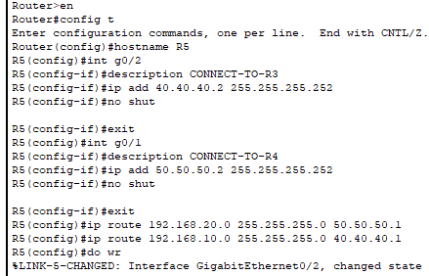

PRIMARY ROUTE

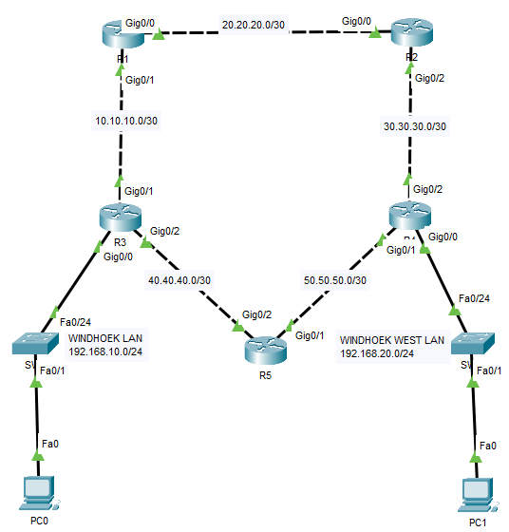

TRACE ROUTE

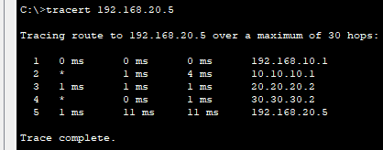

SHUTTING DOWN PRIMARY ROUTE

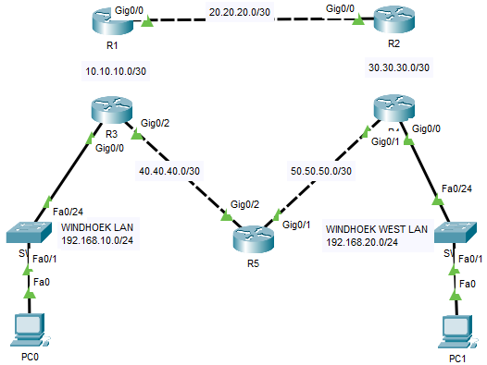

TRACER ROUTE

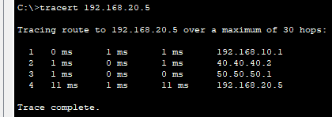

PC0-TO-PC1

